**Chapter 4**

**Recycle Bin Forensics and Link Files**

**V1**

**SID: 2103022**

**Anglia Ruskin Final Project**

**Table of Contents**

**Introduction** 2

**Objective** 2

**1.0** **Recycle Bin Forensics** 3

**2.0 Link Files** 7

# **Introduction**

The fourth chapter covers Recycle Bin Forensics and Link Files (LNK) which allows an investigator to gather large amounts of important information on a suspect’s file deletion usage and application, file or folder opening. The chapter aims to teach the reader how to firstly see the date the file was deleted, the location of the drive and name, file size in bytes and OS version all this information can be used as contributing evidence and see the full path, times of creation and modification along with other evidence that could help an investigator create a timeline of events.

# **Objective**

* See ‘$’ names of deleted files.
* Expand said files to the desktop and parse them to see details.
* Find LNK files to know when an application, file or folder was last opened or edited.

1. **Recycle Bin Forensics**

1.Login as Digital-Forensics and use the password **‘password’** to login to the VM.

2. Search for ‘cmd’ in the search bar and click on ‘Run as administrator’ and click ‘Allow’.

3. Type ‘cd ..’ twice to return to the C:\ drive.

4. Type ‘dir /a’ to list all in the current directory, here we can see $Recycle.Bin.

5. To enter the recycle bin type ‘cd $Recycle.Bin’.

6. List all in directory with ‘dir /a’ to list the users.

7. The names are hidden so to reveal the account we are using ‘Digital-Forensics’ type ‘wmic useraccount get name,sid’.

8. Copy the SID of ‘Digital-Forensics’ like the figure below.

9. On the desktop right click and create a folder called ‘Outcome’.

10. Return to the command prompt and let’s go into the account so type ‘cd’ click space and copy the SID then click enter, you will now see the parses of deleted files.

11. Copy/expand one of those to the desktop using ‘expand $IQN0X31.jpg %userprofile%\Desktop\Outcome’

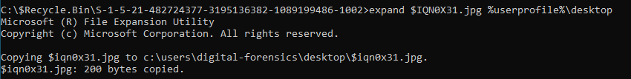

12. Open the ‘$l_Parse.exe’ application located in the tools folder on the desktop.

13. Click the first browse button and find the ‘Outcome’ folder you made in step 10. Click the second browse and locate the desktop and name it text then click ‘Parse!’.

14. A ‘.tsv’ file will appear on the desktop, double click to open it.

15. You can now see the date the file was deleted, the location of the drive and name, file size in bytes and OS version all this information can be used as contributing evidence.



# **2.0 Link Files**

1. Open File explorer by searching for it in the search bar or locating it on the taskbar.

2. Locate the Recent Items folder by following the file path from the figure below which allows us to see the full path, times of creation and modification along with other evidence that could help an investigator create a timeline of events.

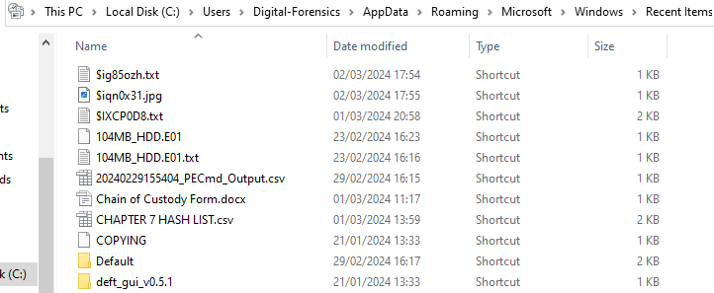

4. The chapter is complete, and you can now see the date the file was deleted, the location of the drive and name, file size in bytes and OS version all this information can be used as contributing evidence and see the full path, times of creation and modification along with other evidence that could help an investigator create a timeline of events. You can close all applications and return to the desktop for Chapter 5 or shutdown if you wish to continue later.